Part 1: Cluster and Infrastructure
In this part, three-node RabbitMQ cluster is covered, like how it starts, and how it behaves when it is broken on purpose. A new leader took over in 55 milliseconds when a leader node is killed.

What is built
- A three-node RabbitMQ cluster in Docker Compose (rabbit1, rabbit2, rabbit3, version 3.13.7) on one network.
- A quorum queue, hw2.orders, copied to all three nodes with the Raft algorithm.
- A start script, ./scripts/up.sh, that brings everything up and creates the queue.
- A failure test script, ./scripts/failure/run_scenario.sh.
- Design notes and a C4 Deployment diagram in docs/.

How the cluster works
There is a fixed list in the config file where the nodes find each other through it and share one Erlang cookie. The queue has one leader and two followers. A message is considered as saved only when 2 of the 3 nodes have written it to disk (floor(3/2)+1=2), so one node can fail without losing a confirmed message. However, if two nodes fail, the queue stops accepting writes. We chose consistency over availability and did not test this case.

Two settings matter most: pause_minority prevents the cluster from splitting into two by making the node that is cut off from others pause. On the other hand, reject-publish makes a full queue refuse new messages instead of silently dropping them. Clients connect on ports 5672, 5673, and 5674, and the management UI runs on 15672 to 15674.

Starting it
./scripts/up.sh starts the containers, waits until all three nodes are healthy and joined, creates the queue and prints which node is the leader. ./scripts/down.sh --purge stops everything and deletes the data.

Failure tests
The test script breaks one thing, records which node is leader, undoes the fault and waits until three nodes are running again. I ran each scenario once on 2026-10-23. Logs are in results/ and screenshots are in docs/evidence/.
Scenario | What I did | Result
S1 | Killed the follower rabbit2 | The leader stayed rabbit1. The cluster was whole again in about 5.5 s.
S2 | Killed the leader rabbit1 | rabbit3 became leader in 55 ms. rabbit1 rejoined as a follower in about 10 s.
S3 | Cut the leader rabbit3 off the network for 64 s | rabbit1 took over. After I reconnected, the cluster was whole again in about 11 s.
In every case the two remaining nodes kept a majority, so the queue stayed available. The restarted node caught up and ended on the same log index as the others (3, 7 and 9 in the three runs).

Limitations
- The cluster was idle during the tests, so they show leader election and recovery, not message loss.
- Each scenario ran once, on one Docker host, with simulated faults.
- The election time for S3 was not recorded, because the management API still showed the old leader when the script checked.

Part 2: Monitoring, Management and Benchmarking
This part covers how the cluster is watched and managed, and how its performance was measured. All monitoring is loaded from files in the repository, so ./scripts/up.sh brings it up with no manual steps in Grafana.

5. Cluster Management and Monitoring

What is built
- Prometheus 2.53.0 scraping all three RabbitMQ nodes every 5 seconds.
- Eight alert rules for node failure, lost majority, memory and disk alarms, backlog, unacked messages, missing consumers and Raft leader elections.
- Grafana 11.1.0 with three dashboards loaded automatically: our own HW2 overview, plus the official RabbitMQ-Overview and RabbitMQ-Quorum-Queues-Raft dashboards.
- Management scripts that show cluster membership, Raft leaders and node health through the CLI and the HTTP API.
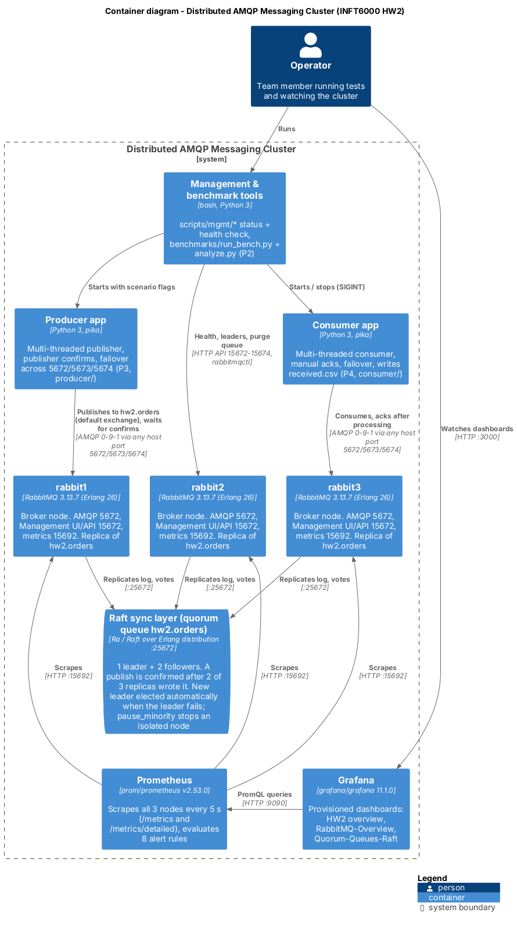
Figure P2-1. C4 Container diagram: three RabbitMQ nodes, the Raft sync layer of the quorum queue, Prometheus, Grafana, the test clients and the tools.

Monitoring pipeline
Each node runs the rabbitmq_prometheus plugin on port 15692. Prometheus uses two scrape jobs. The first reads /metrics, which gives node-level values: message rates, connections, memory, disk and alarms. The second reads /metrics/detailed with the families queue_coarse_metrics, queue_consumer_count and ra_metrics. These are per-queue values such as depth, consumers, Raft term, commit index and commit latency, all with the prefix rabbitmq_detailed_, so they never clash with the first job.
The scrape interval is 5 s because RabbitMQ refreshes its own statistics every 5 s, so a shorter interval only repeats values.
Three problems came up while connecting this to the dashboards:
- The official dashboards filter on a namespace label that our setup did not have, so every panel was empty. I added the static label namespace: hw2 to both jobs.
- The detailed endpoint repeats rabbitmq_identity_info. A second copy per node breaks the join in one panel of the official Raft dashboard, so the detailed job drops that metric.
- For a quorum queue, the queue depth is reported only by the node that is currently the leader. Every queue panel and alert therefore takes max() across the nodes, which stays correct after a leader change.

Dashboards
The HW2 overview dashboard opens as the Grafana home page and has five rows:
Row | Panels | Why it matters for HW2
Cluster health | nodes up, UP/DOWN per node, queue depth, Raft term, firing alerts, alert table | shows a failure in one glance
Message flow | publish / confirm / deliver / ack rate, publish rate per node, redeliveries, connections per node | shows the throughput dip and recovery during a failure, and clients moving to another node
Queue | ready and unacked messages, consumers | shows backlog and consumer health
Raft | term per node, commit index per node, commit latency | a term step marks a leader election; a restarted node catches up when its commit index meets the others
Node resources | memory as % of the watermark, free disk, channels | the limits that trigger RabbitMQ's flow control

Each node keeps the same colour on every panel. Raft elections are also drawn as annotations on the time series.
[FILL: Figure - screenshot of the HW2 overview under normal load (docs/evidence/p2-02-grafana-normal.png)]
[FILL: Figure - screenshot of the HW2 overview during a leader crash under load, showing the rate dip, the Raft term step and the NodeDown alert (docs/evidence/p2-03-grafana-leader-crash.png)]

Alert rules
Alert | Condition | Wait | Severity
RabbitMQNodeDown | a node cannot be scraped | 5 s | critical
RabbitMQQuorumLost | fewer than 2 of 3 nodes up | 10 s | critical
RabbitMQMemoryAlarm | memory watermark alarm active | - | critical
RabbitMQDiskAlarm | free disk below 1 GB | - | critical
RabbitMQQueueBacklog | more than 100,000 ready messages | 1 min | warning
RabbitMQUnackedHigh | more than 10,000 unacked messages | 2 min | warning
RabbitMQNoConsumers | messages waiting and no consumer | 1 min | warning
RabbitMQRaftLeaderElection | the Raft term of a queue changed in the last minute | - | info

The rules have unit tests (monitoring/prometheus/tests/) that promtool runs: one node down, two nodes down, an election, and a queue without consumers. There is no Alertmanager. Alerts appear on the Prometheus alerts page and in the Grafana alert table, which is enough for a test cluster and keeps the stack small.
[FILL: Figure - Prometheus alerts page while a node is down (docs/evidence/p2-04-alerts-node-down.png)]

Management tools
Script | What it does
scripts/mgmt/mgmt_check.py | Health check through the HTTP API. Tries ports 15672, 15673 and 15674 in turn, so it works while a node is down. Prints each node's memory, disk, alarms and partitions, and each queue's leader and online members. Exits 1 if anything is unhealthy.
scripts/mgmt/cluster_status.sh | rabbitmqctl cluster_status and the alarm check on every running node, asked through whichever container is alive.
scripts/mgmt/quorum_status.sh | Leader, members and Raft state of every hw2.* quorum queue, as plain text that can go into logs.
scripts/mgmt/check_prometheus.sh | Checks that all 7 scrape targets are up and that per-queue and Raft metrics arrive.

The shell scripts run on the default bash of macOS (3.2), which has no associative arrays. Only the Python standard library is used, so nothing has to be installed to manage the cluster.
[FILL: mgmt_check.py output with all nodes healthy, and again with one node killed (it should list the stopped node and "2 of 3 members online")]

Limitations
- Prometheus and Grafana run as single instances, so the monitoring itself is not highly available.
- Metrics have 5 s resolution. Sub-second election times therefore come from P1's failure-test logs, not from Prometheus.
- Alerts are only displayed, not sent anywhere.

9. Performance Benchmarking

Setup
All tests ran on one machine: [FILL: Mac model, chip, CPU cores, RAM, macOS version, Docker Desktop version and the CPU/RAM given to Docker]. The cluster is the three-node RabbitMQ 3.13.7 setup from Part 1, with the quorum queue hw2.orders (3 replicas). Messages are persistent. The producer from P3 waits for publisher confirms, and the consumer from P4 uses manual acknowledgements. Clients connect through the host ports 5672-5674.

Method
benchmarks/run_bench.py runs every configuration in benchmarks/scenarios.yaml three times. Before each run it waits until all three nodes are up and the queue has 3 of 3 members online, then empties the queue. The consumer starts 3 s before the producer. The producer publishes as fast as confirms allow for 60 s. The run ends when the queue is empty again.
Group | What changes | Values | Fixed
B1 baseline | - | 1 producer thread, 1 consumer thread | 1 KB, prefetch 100
B2 producer scaling | producer threads | 1, 4, 8, 16 | 4 consumer threads, 1 KB, prefetch 100
B3 message size | body size | 256 B, 1 KB, 4 KB, 64 KB | 4 + 4 threads, prefetch 100
B4 prefetch | consumer prefetch | 10, 100, 500 | 4 + 4 threads, 1 KB

benchmarks/analyze.py ignores the first 5 s of each run as warm-up and computes:
- Publish throughput: confirmed messages per second.
- Consume throughput: first deliveries per second.
- End-to-end latency: receive time minus send time (p50, p95, p99). This is valid because producer and consumer share one clock.
- Confirm latency: confirm time minus send time.
As an independent check, the runner also asks Prometheus for the broker's own publish rate over the same window.
[FILL: Table - paste benchmarks/results/summary.md]
[FILL: Figures - fig_b2_throughput.png, fig_b2_latency.png, fig_b3_latency.png, fig_b3_mbps.png, fig_b4_throughput.png, fig_b4_latency.png, fig_b1_timeseries.png]

Analysis
[FILL after the runs, using these checks. Write only what the numbers show.]
- Producer scaling (B2). Throughput went from [FILL] msg/s with 1 thread to [FILL] msg/s with [FILL] threads. With synchronous confirms, one thread can publish at most about 1 / confirm latency messages per second. Comparing this with the measured confirm p50 of [FILL] ms shows whether a single thread is limited by the Raft round trip. Beyond [FILL] threads throughput [FILL: kept rising / flattened], while p99 latency rose from [FILL] to [FILL] ms.
- Message size (B3). In messages per second, throughput fell from [FILL] at 256 B to [FILL] at 64 KB. In MB/s it [FILL: rose / stayed flat]. Every message is written to disk on 2 of 3 nodes before it is confirmed, so large messages cost replication bandwidth and disk writes.
- Prefetch (B4). Prefetch [FILL] gave the best throughput. A small prefetch makes consumers wait for the next delivery. A large prefetch keeps more messages unacked inside the consumer, which [FILL: did / did not] raise end-to-end latency (p99 [FILL] ms at prefetch 500).
- Broker cross-check. The broker's publish rate from Prometheus was within [FILL] % of the client-side numbers, so the client measurements are consistent.

Limitations
- All three nodes share one machine, so Raft replication never crosses a real network, and the nodes compete for the same CPU and disk.
- On macOS, Docker runs inside a virtual machine, which adds disk and network overhead.
- The clients are Python programs. At high thread counts the client itself may be the bottleneck rather than the broker. The CPU use of the client and of the containers should be checked in the heaviest run: [FILL: what Activity Monitor or `docker stats` showed].
- Each configuration ran three times. The standard deviations show the run-to-run noise.

Appendix A: Reproduction Runbook
All commands run from the repository root on macOS or Linux, with Docker Desktop running.

1. Start everything
cp .env.example .env
chmod +x scripts/*.sh scripts/failure/*.sh scripts/mgmt/*.sh scripts/mgmt/*.py
./scripts/up.sh
Wait for "Cluster is ready". The services are:
Service | Address | Login
Management UI | http://localhost:15672 (also 15673, 15674) | admin / admin123
Prometheus | http://localhost:9090 | -
Grafana | http://localhost:3000 | admin / admin

2. Check monitoring and management
./scripts/mgmt/check_prometheus.sh # expect 7 targets UP and RESULT: OK
python3 scripts/mgmt/mgmt_check.py # expect RESULT: HEALTHY
./scripts/mgmt/quorum_status.sh # leader + 2 followers of hw2.orders
./scripts/mgmt/cluster_status.sh
Grafana opens on the "HW2 - RabbitMQ cluster overview" dashboard. The two official dashboards are in the folder "HW2 RabbitMQ".

3. Test the alert rules
docker run --rm -v "$PWD/monitoring/prometheus:/p" --entrypoint promtool \
prom/prometheus:v2.53.0 test rules /p/tests/rabbitmq-alerts.test.yml

4. Run the benchmarks
python3 -m venv .venv && source .venv/bin/activate
pip install -r benchmarks/requirements.txt
benchmarks/selftest/selftest.sh # tests the pipeline with fake clients (numbers are not real)
python3 benchmarks/run_bench.py --dry-run # shows the 33 runs
python3 benchmarks/run_bench.py # about 70 minutes; re-run to resume
python3 benchmarks/analyze.py # tables and charts in benchmarks/results/
Do not run a failure test while a benchmark is running: both use the queue hw2.orders.

5. Failure tests
See Part 1: ./scripts/failure/run_scenario.sh leader-crash (or follower-crash, partition, rolling-restart). Keep the HW2 overview dashboard open on "Last 15 minutes" to capture the dip and the recovery.

6. Stop
./scripts/down.sh # keep data
./scripts/down.sh --purge # delete all volumes for a clean start

Troubleshooting
Problem | Fix
Grafana panels say "No data" | Check ./scripts/mgmt/check_prometheus.sh; in the official dashboards pick Namespace = hw2
Changed alert rules not loaded | docker compose restart prometheus
Changed dashboards not shown | python3 monitoring/grafana/build_hw2_dashboard.py, then wait 30 s or docker compose restart grafana
Port 3000 or 9090 in use | Stop the local Grafana/Prometheus, or change the host port in docker-compose.yml and tell P1
run_bench.py: cluster not healthy | A node is still down from a failure test: docker compose ps, then docker start rabbitN

